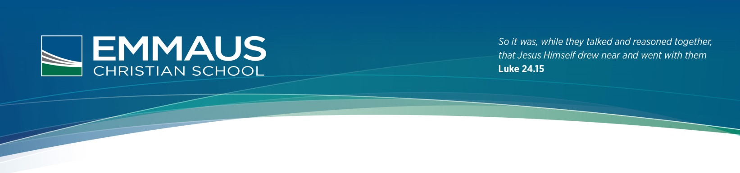

Students in Years 9 & 10 will be required to bring their own devices (BYOD), which involves the students bringing mobile tablets, laptops or netbooks (Device must have a minimum screen size of 17.5cm) for educational use within the classroom.

**Year 9 & 10 Bring Your Own Device User Agreement (BYOD) 2016**

### Under the guidelines of this policy the students will:

* Bring the device to school each day **fully charged**.
* Use the device for educational purposes only and **not access anything that their teacher has not requested** such as games, social media, Youtube or websites.
* Not use the device at recess or lunch without written permission from a staff member.
* Ensure that the device is in a sturdy case that is free from any form of graffiti, stickers or markings other than the student’s name.
* **Back up all documents and information** on their device. Loss of work is not an acceptable excuse for late assignments or homework.
* **Be aware that all material on the device is subject to review by School Staff if requested**.
* 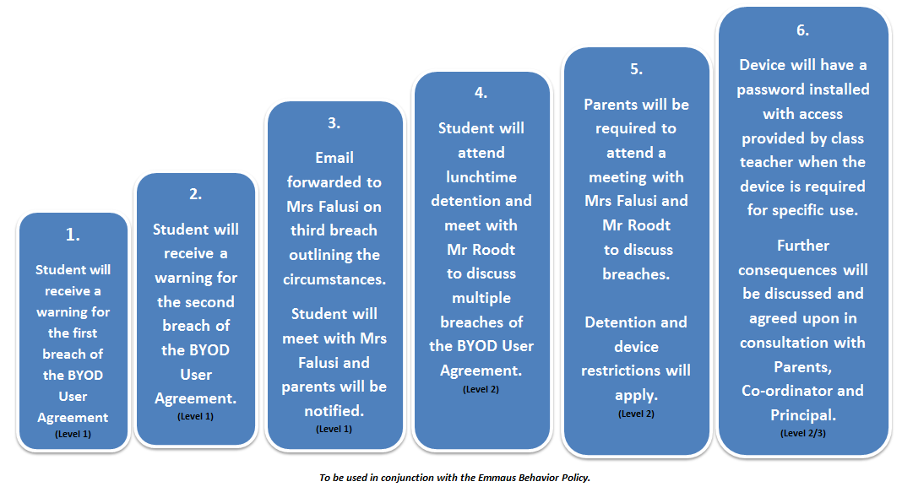Be aware that the devices are the responsibility of the owner and Emmaus Christian School will not be responsible for any damage or loss.
* Ensure that the device is covered by the parent/carer’s insurance in case of damage or loss.  
  Adhere to Emmaus’s Student Network and Technology Agreement.
* Accept consequences outlined if they breach the use of the Device.
* Not allow others to use their device.

***It is important to note it is compulsory for students in Years 9 & 10 to participate in this BYOD programme.***

✂  
 *Students and parents/carers must carefully read this agreement prior to signing it. Any questions should be forwarded to Mrs Toni Falusi* [*toni@emmaus.act.edu.au*](mailto:toni@emmaus.act.edu.au) *and clarification obtained before the agreement is signed.*

|  |  |  |  |  |
| --- | --- | --- | --- | --- |
| BYOD User Agreement 2016 | | | Please initial | |
|  | | | Student | Parent/ Carer |
| I have read the BYOD User Agreement and I acknowledge that I understand and agree to the guidelines, including consequences for any breach. | | |  |  |
| The device is covered by the parent/carers insurance in case of damage of loss. | | |  |  |
| I understand that failure to comply with the BYOD User Agreement will result in the consequences outlined in the document. | | |  |  |
| I have read the Student Network and Technology Agreement 2016 and have discussed it with my child. | | |  |  |
|  |  | | |
| Device Serial Number |  | | |

Student’s name (print)______________________________ Year ________ Homeroom Teacher: _____________

_________________________________________ _________________________________________ Student’s Signature Parent/Carer’s Signature (Mother/Father/Other)  
Date: Date:

**PLEASE SIGN AND RETURN TO YOUR HOMEROOM TEACHER**